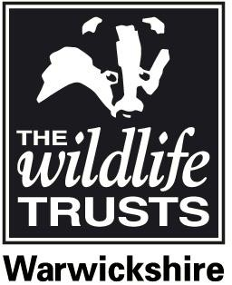
EQUAL OPPORTUNITY MONITORING

Warwickshire Wildlife Trust is an Equal Opportunities employer. The Trust operates a policy that aims to ensure that unfair discrimination does not take place. The information requested below will help us to monitor the effeciveness of our recruitment. The details supplied are confidential and will not be made available to the recruitment team.
Please complete this form and return it with your application to the address below. Thank you for your help.
Post applied for:
_

Gender Male Female

Date of Birth

Are you disabled? Yes No

If yes, have you applied under the Job Interview Guarantee scheme?

Yes No

Where did you see this post advertised?

Local press Please specify:

National press Please specify:
WWT Website Other website
Please specify:
Job Centre Other
Please specify:

Return this completed form to: Nichola Wood, Warwickshire Wildlife Trust, Brandon Marsh Nature Centre, Brandon Lane, Coventry, CV3 3GW
To which of these groups do you consider you belong (tick one box only)?*

A White
A1 British A2 Irish
A3 Any other White background

B Mixed
B1 White and Black Caribbean B2 white and Black African
B3 White and Asian
B4 Any other mixed background

C Asian or Asian British
C1 Indian C2 Pakistani
C3 Bangladeshi
C4 Any other Asian background within category D

D Black or Black British
D1 Caribbean D2 African
D3 Any other Black background within category D

E Any other ethnic group
E1 Chinese
E2 Any other ethnic group E3 Not stated
*The ethnic groupings are those agreed by the
Commission for Racial Equality.

