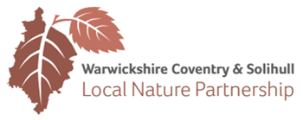

Membership of the Local Nature Partnership Board for
Warwickshire, Coventry and Solihull November 2017

Sector | Board Member and employing/contact organisation | Deputies
Health | John Linnane to advise  Warwickshire County Council | Steve Munday, SMBC;
Education | Rosemary Collier  University of Warwick | James Bennett,  Coventry University
Business | Paul Rice, Wright Hassall  Chair from 15.11.16
Local Economic Partnership | To be agreed
Government agencies | Yvonne Jones  Natural England | Environment Agency
Community | Paul Cobbing
Landowners | Henry Lucas  Farmer | Sarah Faulkner, NFU, proposed
Environment | Ed Green,  Warwickshire Wildlife Trust
Local Authorities:  County/CCC | David Lowe  Warwickshire County Council | Coventry City Council
Local Authorities, link to Greater Birmingham and Solihull LEP | Maurice Barlow  Solihull MBC | Mike Eastwood,  Solihull MBC
Local Authorities: District Councils | Bill Hunt  Warwick District Council | Helena Lidgate  Nuneaton and Bedworth Borough Council
Chair of Implementation Group | Gina Rowe  Warwickshire Wildlife Trust

