Suggested consultation response

Q S1: Strategic Green and Blue Corridors
Q-S1: Please select the option which is most appropriate for South Warwickshire
South Warwickshire Councils need a clear policy to protect important environmental assets, designated and non designated sites including potential local wildlife sites. As well as a policy to enhance and restore wildlife sites. Without watering down the policy with wording such as ‘where appropriate’ and in line with the priorities of the Biodiversity Action Plan.

The Councils need to plan in line with the legal requirements set out in the National Planning Policy Framework (NPPF), 25 year Environment Plan, the Governments commitment to 30% land in nature recovery by 2030, COP 27 and COP 15 and the Councils declared climate change emergencies.

National Planning Policy Framework Paragraph 20d) requires ‘conservation and enhancement of the natural…environment, including landscapes and green infrastructure, and planning measures to address climate change mitigation and adaptation’
Paragraph 175. Requires Councils ‘take a strategic approach to maintaining and enhancing networks of habitats and green infrastructure; and plan for the enhancement of natural capital at a catchment or landscape scale across local authority boundaries’.

QS1a Yes this should study be produced in advance of the Nature Recovery Network, as it is a very important bit of local work and needs to inform ‘Sound’ locations of growth. This is also a legal requirement in the NPPF.

The 2013 Green Infrastructure study is also now 10 years out of date, and considered very outdated. This needs to be reviewed early on and in detail, in order to deliver joined up habitats and influence the spatial options. This should be produced based on Natural England’s new GI Framework Green Infrastructure Home (naturalengland.org.uk) The Nature Recovery Strategy will also take some time to produce, so we need a policy in the interim.

Q-S7.2: For each growth option, please indicate whether you feel it is an appropriate strategy for South Warwickshire.
Q-E7.1: Please select the employment option which is most appropriate for South Warwickshire
We are concerned that the plan hasn’t considered local biodiversity in enough detail in their growth strategies, with a number of growth areas directly adjacent to the important River Avon and River Leam and their tributaries. As well as a number of key Local Wildlife Sites.
The Councils also urgently need to assess their ‘Potential Local Wildlife Sites’ to give them more weight, especially in the south as these should have full LWS status, and should be informing the growth strategy.

We are particularly concerned that the ‘Dispersal option’ includes a number of large settlement actually in the Area of Outstanding Natural Beauty (AONB), this isn’t considered a legally sound Option in line with the Sustainability Appraisal. The NPPF states ANOB should only be considered in exceptional circumstance and Para 76. States ‘the scale and extent of development within all these designated areas should be limited’.

We are concerned that a number of important Local Wildlife Sites and Potential LWSs are located in the proposed growth areas, including a number of key SSSIs and the Nature Improvement Area:
Leamington- Warwick Racecourse Nursery Wood and Newbold Comyn LWS’s and the Grand Union Canal LWS.
Southam- Long Itchington quarry, Bishops Hill and Bishops Bowl LWS, Ufton Hill Farm Fields PLWS
NE- Thickthorn wood stoneypark wood
NW- Hays wood River Alne, Coughton Park LWS
South- River Stowe LWS
West - River Arrow, Springs, Three Oakhill, The Belts Wood and Old Pack Woo LWS
SW- Long Marston Disused Airfield and Doctors Farm LWS
SE- DM Kineton, Bomb crater pool
North- Henley Meadows LWS
Dispersed method -includes Oversley Wood LWS amongst others

Q-S5.2: Do you think New Settlements should be part of the overall strategy?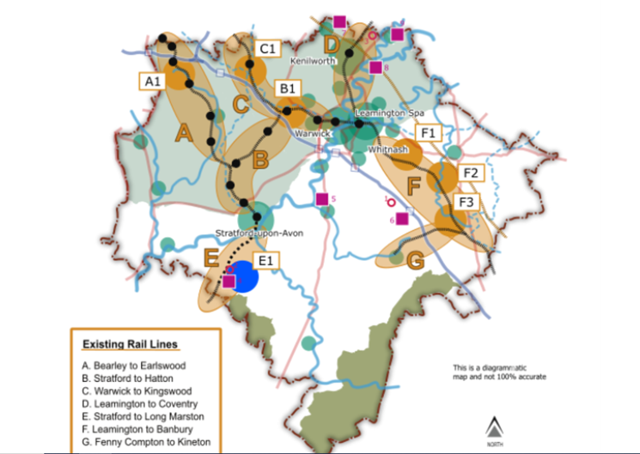

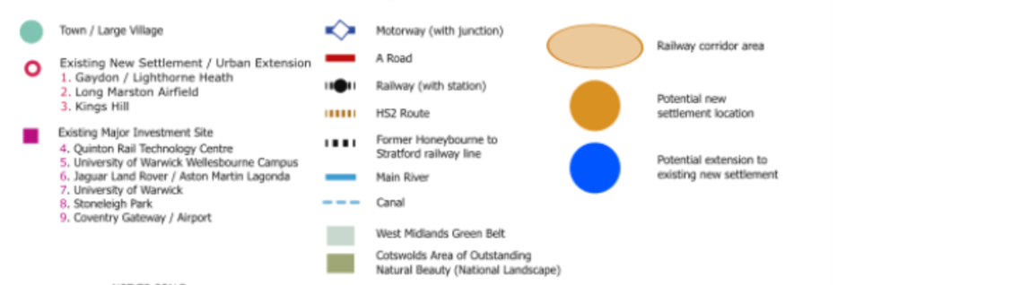

WWT is very concerned regarding the proposed locations of a whole new settlement, due to the proximity of a number of important SSSIs, river habitats, the Nature Improvement Area, Local Wildlife Sites and Potential LWS which don’t seem to have been considered at all in the assessment.

To the north, Crackley wood LNR, Kenilworth common LNR, Parliment piece and knowle hill LNR, River Sowe, Hill woottton farm meadows PLWS, Stoneleigh park, Wainbody and Kenilworth Road Woods LWS, Wootton spinneys PLWS, Grand Union Canal PLWS,
NW- Bannams wood SSSI, Ullenhall meadows SSSI, River Alne LWS, Wedgnock Rifle Range PLWS, Palefield Coppice and Inchford Brook Woods to NW, Rough Hill woods SSSI, Ipleys Alders SSSI, Redditch woods LNR, North Brook Spinney PLWS and Hatton Jct PLWS,
SW- Cleeve Prior bank LNR, River Avon and tributaries LWS, The Greenway, Dismantled Railway, Lower Gorse and Sheepleys Covert and Charlecote Park.
West -Snitterfield and bearley bushes SSSI, Comill Hill SSSI, Sherbourne meadows SSSI
South east- Long Itchington and Ufton woods SSSI, and Ufton Fields SSSI and Harbury Railway SSSI, Ufton Hill Farm PLWS and fields and Bishops Hill and Bishops Bowl LWS, Land adjacent to SSSI, whitnash brook LNR, amongst others.

Q-S7.1: Please provide any comments you have on the emissions estimation modelling for the five growth options
Concerned that NOT reviewing the green belt hasn’t been considered as a clear option, in line with Sustainability Appraisals requirements. This key designation retains open areas for wildlife, stops settlements joining and works with designations outside of S Warks.
With more people working from home, we also consider that other services rather than just the transport network should be included in the assessment. Greater weight should have also been given to impact on biodiversity and LWS’s and PLWSs.

H42 Please add any comments you wish to make about the scale of the shortfall from the Birmingham and Black Country HMA that South Warwickshire should accommodate within the South Warwickshire Local Plan.
The area shouldn’t choose to take more extra additional growth, this would put additional serious pressure on important habitats and environments in the area. The other Councils need to legitimately look to find land/ increase housing densities in their local areas.

Q-C10.1a: Should plan include a policy requiring new development and changes to existing buildings to undertake a Climate Change Risk Assessment.
Yes WWT supports the use of Climate change assessments, but the Council needs a clearer plan for actually delivering and monitoring in line with the climate change priories of COP27, the Governments Climate change strategy and in line with the declared Climate Change Emergencies in both Council areas.

Option C11b: Should plan include Water quality policy
Yes WWT support separate water policy and updated evidence base, especially if national policy is being reduced by the ‘EU Regulation Bill’. Which could result in the loss of the Water Framework Directive which sets out rules to halt the deterioration of water bodies and achieve good status for rivers, lakes and groundwater.
Therefore we need local policies halting the deterioration of water bodies being lost from Water Framework in line and with the Governments 25 year Environment Plan, Climate Change Act (2019) and Environment Act (2021).

The Councils should also include a SUDs policy, as these can be strategic in nature.

Option B3a: Introduce Special Landscape Areas across all of South Warwickshire. Option B4b: Include a buffer around the periphery of the Cotswold AONB.
Yes WWT supports the designation of more Special Landscape Areas in key areas and B4 a separate ‘Area of Outstanding Natural Beauty’ and buffer policy, which is a particularly important area for protection in Warwickshire. We also need detailed worded policies fully protecting and enhancing the areas key wildlife habitats from unnecessary growth.

Q-B5: Please select the option which is most appropriate for South Warwickshire Option B5a: Explore and pursue an integrated or separate Environment net gain policy?
WWT is disappointed to see that over 10%, 20% Biodiversity Net Gain which we proposed isn’t even being explored as an option, at this scale of joint plan making. A plan of this scale should be being a lot more ambitious, as other Councils have been such as Greater Cambridgeshire which requires 20% BNG.

Risk with integrated ‘Environment’ net gain policy of watering down the 10% biodiversity net gain, and allowing the development industry to wriggle out of the legal biodiversity requirements set in the Environment Act.

Q-B6: Should the South Warwickshire Local Plan introduce Wildbelt designations?
Yes very pleased to see our designation that we advocated for included, the Wildlife Trusts new Wildlbelt policy to protect key land for nature recovery. As there needs to be a clear evidence of how the Councils will achieve the Governments targets of ‘30% of land in environmentally sensitive management by 2030’ and in the ‘Pledge for Nature’ with the United Nations and UN Sustainable Development Goals, as well as the commitments in the 25 year Environment Plan.

The plan need a clear policy for how the councils will achieve this legal requirement and plan making Is a key opportunity to achieving this.

Q-B8.2: When considering climate change, biodiversity and economic wellbeing, are there any rural land uses or locations that should be prioritised over others?
Yes need additional protection and buffers on the river Avon, Leam and their tributaries, Local Wildlife Sites and PLWS’s, Local Nature Reserves, SSSIs, Ancient woodland, Local Green Spaces, Ecosites etc.
Councils need to reassess their Potential Local Wildlife Sites as a matter of urgency, as particularly in the south there are huge gaps in this very important evidence base.

Q-B9: Should the plan include a policy requiring the safeguarding of sites of national importance, sites of local importance, and other non-designated sites known to make a positive contribution to biodiversity; unless the benefits of the proposal clearly outweigh the need to protect the site. Where possible conserve and enhance these sites.
Yes in order to meet national requirements and targets set out in the 25 year Environment Plan, COP15 biodiversity framework targets, and the Governments commitment to have 30% more land In nature recovery by 2030, and Councils NERC duties there clearly needs to be a specific policy protecting biodiversity and importantly other non-designated sites such as Potential Local Wildlife Sites, Nature Reserves and Ecosites.

It is also very important to include a policy on enhancing these sites, the words ‘unless clearly outweighs..’ should be removed as this waters down the requirement, and will greatly affect the Councils ability to achieve the Government and COP targets.

